Image de <a href="https://fr.freepik.com/photos-gratuite/veterinaire-prenant-soin-chien-compagnie_20823300.htm#query=pate%20chien%20main&position=20&from_view=search&track=ais">Freepik</a>

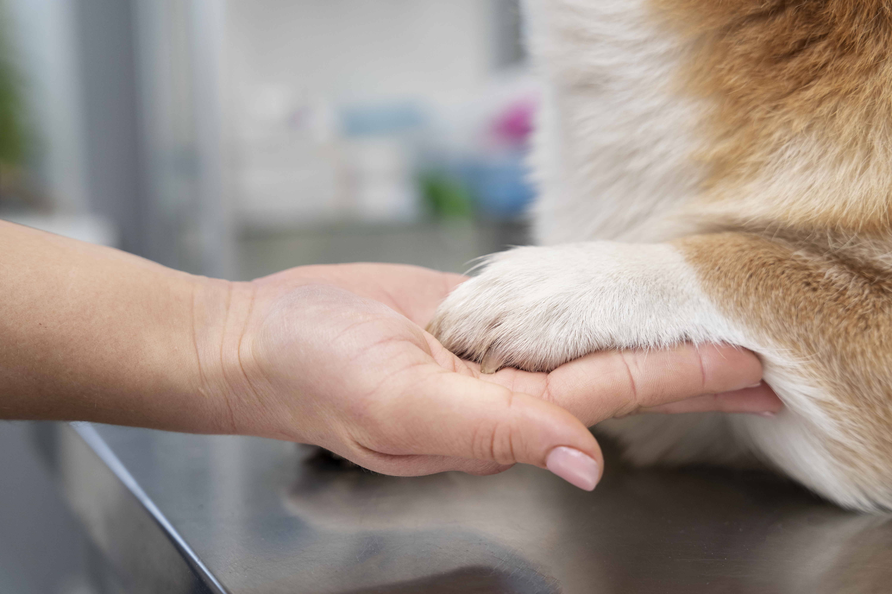
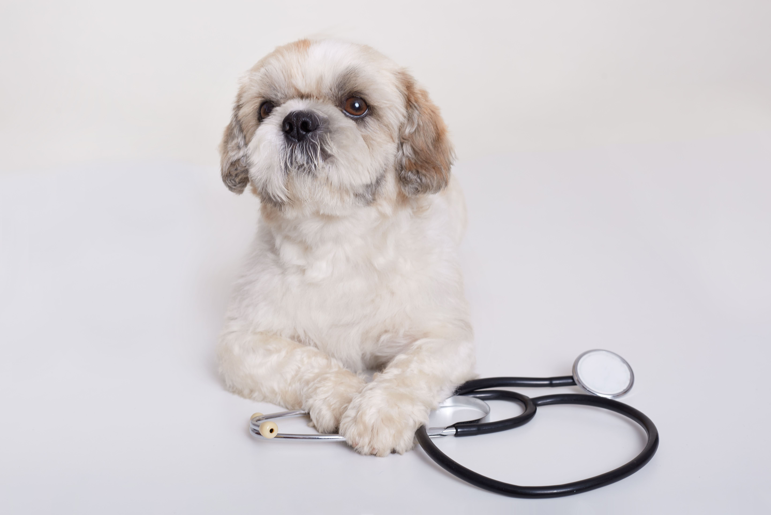
<a href="https://fr.freepik.com/photos-gratuite/chien-chiot-pekinois-stethoscope-pres-ses-pattes-posant_9083141.htm#query=pekinois%20docteur&position=12&from_view=search&track=ais">Image de user18526052</a> sur Freepik

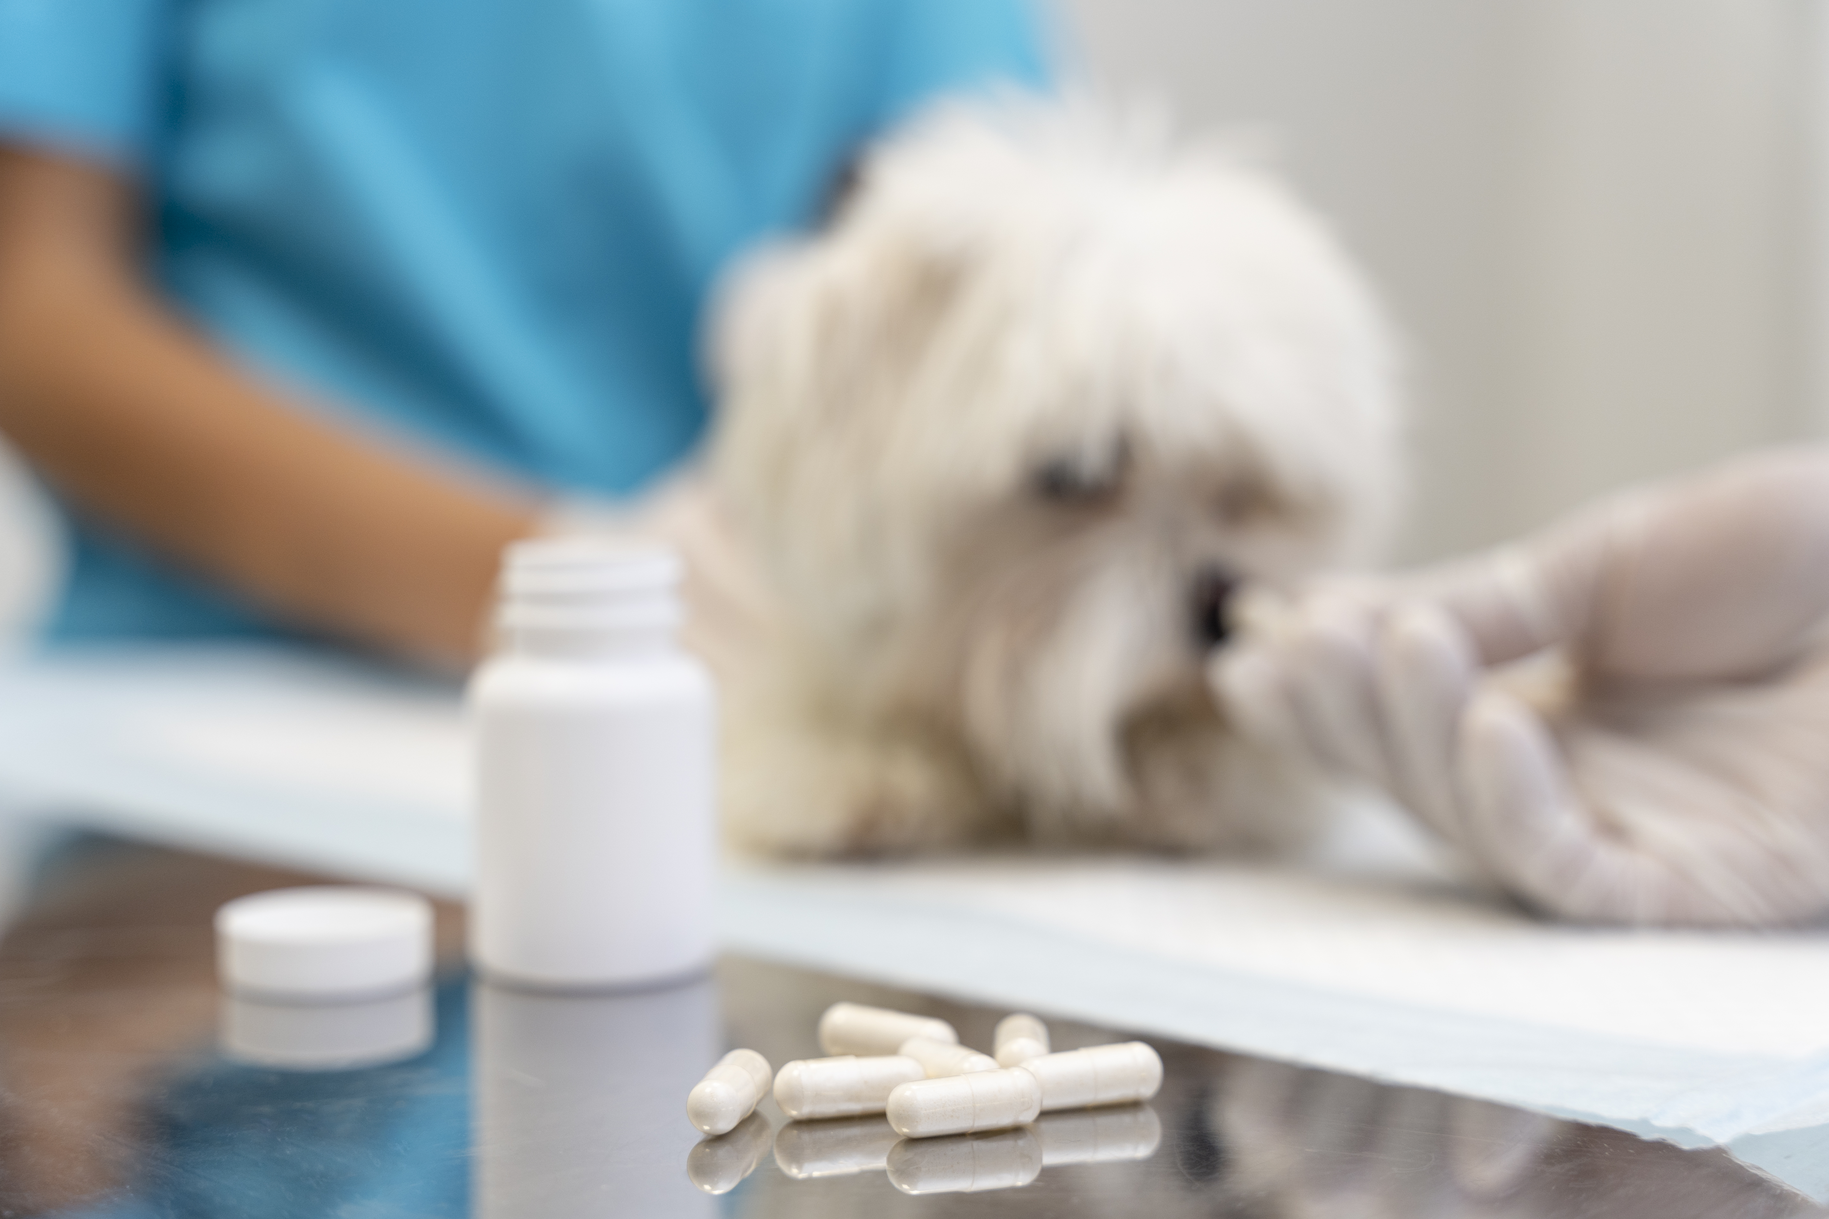
Image by <a href="https://www.freepik.com/free-photo/close-up-veterinarian-taking-care-pet_21080885.htm#query=chien%20m%C3%A9dicament&position=3&from_view=search&track=ais">Freepik</a>

<a href="https://www.freepik.com/free-photo/cute-persian-cat-with-recovery-cone-after-surgery-veterinarian-woman-man-vet-putting-bandage-sick-fluffy-pet-animal-clinic_27999756.htm#query=chat%20v%C3%A9t%C3%A9rinaire&position=2&from_view=search&track=ais">Image by tonodiaz</a> on Freepik

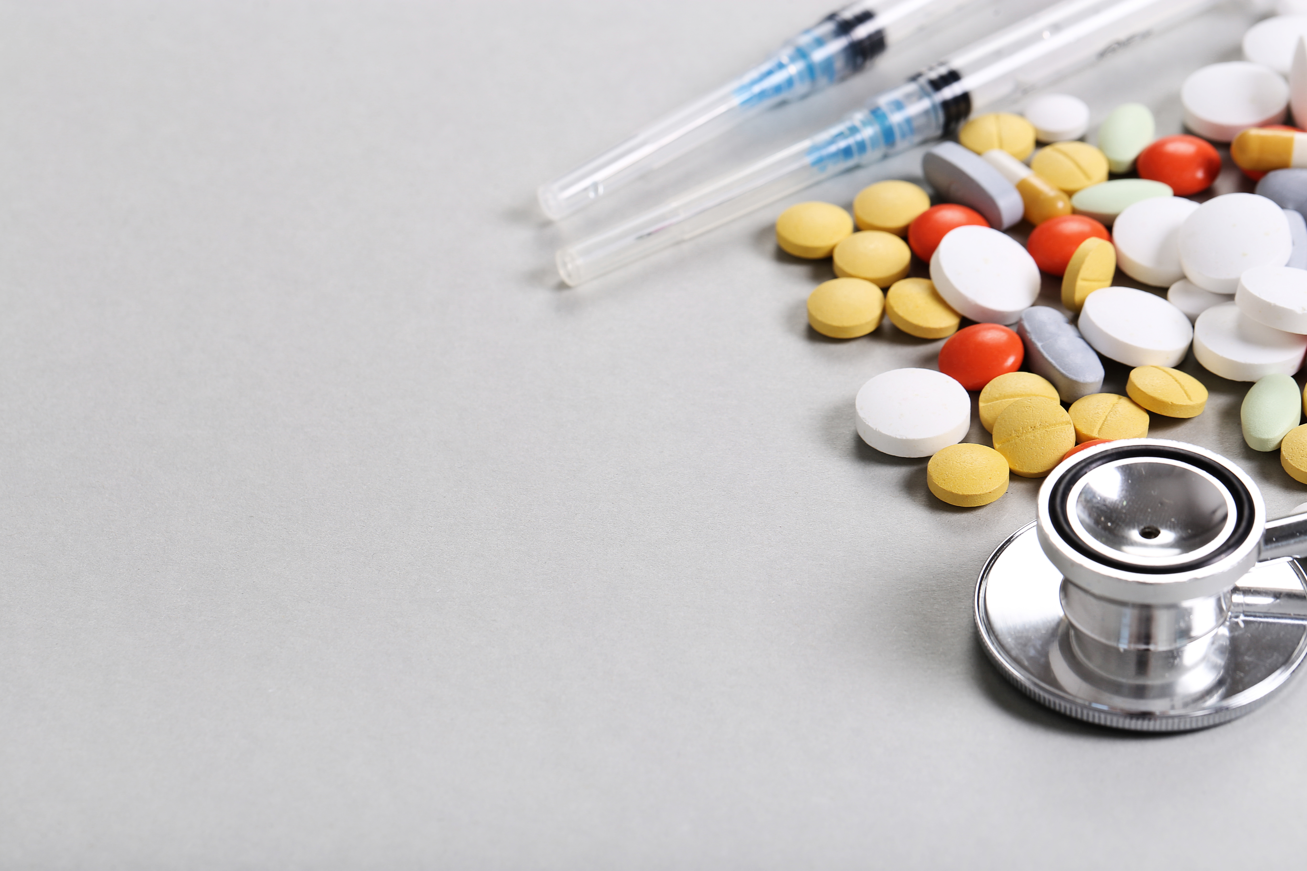
<a href="https://www.freepik.com/free-photo/pills-stethoscope-syringe_9185524.htm#query=m%C3%A9dicaments%20v%C3%A9t%C3%A9rinaire&position=46&from_view=search&track=ais">Image by Racool_studio</a> on Freepik



Image de <a href="https://fr.freepik.com/photos-gratuite/personne-tenant-ampoule-capuchon-graduation_10752872.htm#query=pratique&position=4&from_view=search&track=sph">Freepik</a>

